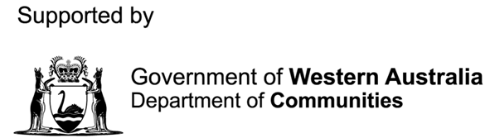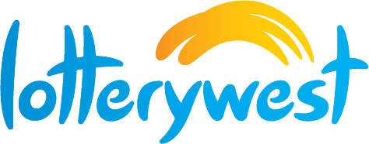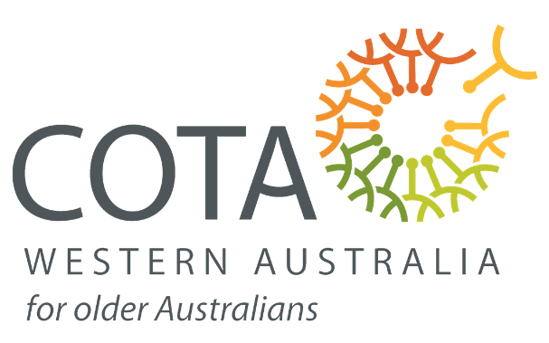

12-19 November 2023

Community Grants Program

2023

WA SENIORS WEEK

**Introduction**

WA Seniors Week 2022 is a special time of celebration for Western Australian seniors. From **Sunday 12 to Sunday 19 November 2023**, events and activities are held across Western Australia to acknowledge seniors and show our appreciation for their valued contribution to the community.

COTA (WA), supported by the Department of Communities and Lotterywest, invites local governments, registered not for profit organisations and community groups in Western Australia to apply for funding to host an event or activity during Seniors Week in Western Australia. The grants provided are intended to celebrate the role of seniors in our communities and encourage participation in community life, particularly for isolated individuals.

**Community Grants Available**

Grants of up to $1,000 are available to local governments, registered not for profit organisations and community groups (or up to $3,000 for a consortium) throughout the metropolitan, and in particular, rural and remote regions of Western Australia to support seniors, particularly those who experience disadvantage or isolation, to attend events and activities during Seniors Week 2023. Each recipient organisation will be asked to provide a summary of the event and acquittal of funds.

Please email your event proposal to Dana Moore at COTA (WA) | Email: [dana@cotawa.org.au](mailto:dana@cotawa.org.au)

The Seniors Week 2023 Community Grants events proposals must be submitted and received by **COB Friday 29 September 2023.**

**Objectives**

The Seniors Week 2023 Community Grants Program provides financial assistance to organisations hosting local events in metropolitan and regional areas of Western Australia.

**Events should meet at least one of the following aims of the week which are:**

* To recognise and thank seniors for their contribution to the community.
* To promote intergenerational activities linking seniors to the community.
* To facilitate artistic, cultural and celebratory expression within the community.
* To engage seniors in a variety of activities and initiatives that encourage active ageing.

**Proposals are strongly encouraged for events aimed at seniors who:**

* Would not normally participate in Seniors Week activities or events.
* Are at risk of becoming socially isolated.
* Are members of Indigenous and Culturally and Linguistically Diverse communities and LGBTQI communities.

**What can be Funded**

Funds received through this program may be used as a contribution towards program costs. Such expenses may include, but are not limited to:

* Administrative expenses
* Advertising and promotion
* Catering, food and drink
* Entrance and/or admittance fees
* Insurance
* Project materials
* Staff wages
* Transport costs
* Venue and equipment hire
* Other miscellaneous expenses

**What cannot be Funded**

The grant **cannot** be used for:

* Purchasing capital items or infrastructure, including equipment, furniture, machinery, etc.
* Purchasing alcohol

Retrospective funding will not be made available.

**Special Conditions of Grant**

* Funded activities and events to be held during Seniors Week 12-19November 2023. This may vary due to COVID restrictions.
* If the Project involves working with children, the Organisation must ensure that all employees and volunteers comply with the *Working with Children (Criminal Record Checking) Act 2004*. Please refer to this website for further information, at: [https://workingwithchildren.wa.gov.au](https://workingwithchildren.wa.gov.au/) or contact the Grantor by email, at [screeningunit@communities.wa.gov.au](mailto:screeningunit@communities.wa.gov.au).
* The Grantor is not liable for any accident or negligence resulting in any claim or damage arising from activities undertaken as part of the Grant. In this respect, the Organisation is required to be appropriately incorporated and be responsible for its own insurances. This includes but is not limited to, Public Liability, Volunteer Insurance and Professional Indemnity.
* The Parties agree that the State will not, by virtue of the Grant, obtain ownership of any intellectual property in or in relation to any material developed by the Organisation (other than material created by the State or provided to the Organisation by the State).
* The Organisation grants to the State a perpetual, irrevocable, royalty-free, world-wide, non- exclusive licence to use, reproduce, adapt and publish the whole or any part or parts of all promotional materials, resources, data and reports brought into existence by or for the Organisation in connection with this Agreement or the Organisation’s use of the Grant.
* The Organisation must ensure that participants in the Project are not exposed to significant promotions of alcohol or unhealthy food and drinks during the Project.
* The Organisation must adhere to State Government directions on [COVID-19 Safety Plans](https://www.wa.gov.au/government/document-collections/covid-safety-plan-and-guidelines) [and Guidelines](https://www.wa.gov.au/government/document-collections/covid-safety-plan-and-guidelines). Further information can be found online at:
* State directions for COVID-19 Safety Plan and Guidelines: <https://www.wa.gov.au/government/covid-19-coronavirus>
* WA Recovery Plan: <https://www.wa.gov.au/government/publications/wa-recovery-plan>

An acknowledgement of funding assistance provided by the Grantor must be included in any advertising and on any material relating to the Project by displaying the Grantor’s logo and using the words ‘Supported by the Department of Communities’ and ‘Supported by Lotterywest’. Copies of the logos and guidelines for its use are available by contacting the Grantor.

**Submitting your Application**

Please email your event proposal to Dana Moore at COTA (WA) | email [dana@cotawa.org.au](mailto:dana@cotawa.org.au)

**If you do not receive a receipt within seven (7) days, please contact us to ensure that we have received your submission.**

**Applications must be submitted and received by:**

**COB Friday 29 September 2023.**

**Submissions Process**

Once submissions are received, representatives from the Department of Communities and COTA (WA) will meet to review submissions and all applicants will be advised of approval and funding allocation; it is anticipated that this process will be completed by **Monday 16 October 2023**.

**Application Form**

**Seniors Week 2023 Community Grants Program**

**Section 1 - Details**

|  |  |  |  |  |  |  |  |  |  |
| --- | --- | --- | --- | --- | --- | --- | --- | --- | --- |
| Name of Organisation: |  | | | | | | | | |
| Contact Person: | Title: | First name: | | | | Surname: | | | |
|  |  | | | |  | | | |
| Position Title: |  | | | | | | | | |
| Postal Address: |  | | | | | | | Postcode: |  |
| Phone: |  | | | Mobile: | | |  | | |
| Email: |  | | | | | | | | |
| **Email will be used for all correspondence relating to this submission.** | | | | | | | | | |
| Type of organisation: | 🞎 Not-for-profit 🞎 Local Government  🞎 Religious / Charitable | | | | | | | | |
| Do you have an ABN? | 🞎 Yes 🞎 No | | ABN: | |  | | | | |
| Are you registered for GST? | 🞎 Yes 🞎 No | |  | | | | | | |
| Is the organisation incorporated? | 🞎 Yes 🞎 No | |  | | | | | | |

**Section 2 - Event Details**

|  |  |  |  |  |
| --- | --- | --- | --- | --- |
| Event title: |  | | | |
| Date of event: |  | |  |  |
| Venue or location: |  | | | |
| Expected numbers: |  | | Is the event open to the public? | 🞎 Yes 🞎 No |
| Does your event support? | | 🞎 ATSI 🞎 CaLD 🞎 LGBTIQ+ 🞎 Socially isolated  🞎 Disadvantaged 🞎 Regional | | |

**Section 3 - Selection Criteria**

Please complete the following questions in the space provided below to support your application.

|  |
| --- |
| In no more than 200 words, describe your event. What are you planning to do? |
|  |

|  |
| --- |
| How much funding are you requesting? |
|  |

**Section 4 - Agreement**

I confirm that the details contained in this application and its attachments are true and correct.

*I understand that if this application is approved*:

1. My signature below is an agreement to abide by the undertakings and conditions of the community grant as outlined in a confirmation letter that will be sent to my organisation in August-September 2023.
2. By **COB, Monday 11 December 2023**, I will provide acquittal of the funds received under this grant program, which have been spent in accordance with the guidelines.
3. I agree that any unexpended grant funds will be returned to COTA (WA) by **COB Monday 11 December 2023**.
4. I agree to have my funded event listed in the WA Seniors Week 2023 events calendar published in the media and online.
5. COTA (WA), The Department of Communities and Lotterywest as outlined in the confirmation letter will be acknowledged in all publicity and promotion of this event.

|  |
| --- |
| Signed: |
| Position: |
| Date: |

**Section 5 - Payment Details**

In order to expedite payment if your application is successful, please provide your bank account details below.

|  |  |
| --- | --- |
| **Name of Organisation** |  |
| **Event Title** |  |
| **Contact Person** |  |
| **Contact Phone** |  |
| **EFT Details:** | |
| **Account Name** |  |
| **BSB** |  |
| **Account Number** |  |

**Submit your Application**

**Applications to be submitted by COB Friday 29 September 2023 via email to Dana Moore:** [**dana@cotawa.org.au**](mailto:dana@cotawa.org.au)

**The 2023 Community Grants Scheme is supported by The Department of Communities WA and Lotterywest.**



**For further information about the WA Seniors Awards 2019 Nominations Pack**

**Please contact COTA (WA) on**

**08 9471 0104 or E-mail** [**dana@cotawa.org.au**](mailto:dana@cotawa.org.au)

**NOMINATIONS OPEN ON MONDAY 19TH AUGUST 2019 AND**

**CLOSE 5:00PM FRIDAY 4TH OCTOBER 2019.**