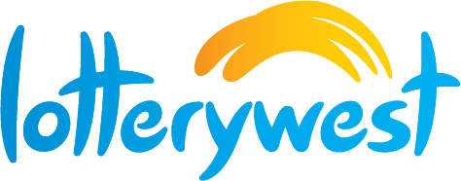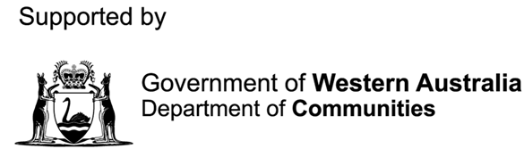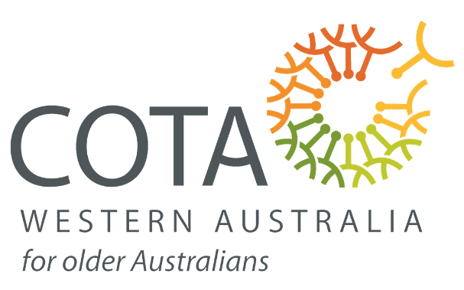

2023

Nominations

WA SENIORS AWARDS

## **Introduction**

The WA Seniors Awards recognise the important contribution of seniors to the community, as well as those who work to improve the lives of older Western Australians.

The 2023 WA Seniors Awards are coordinated and presented by the Council on the Ageing (WA) in partnership with the State Government.

The WA Seniors Awards 2023 will be promoted State-wide as an open application process. Anyone can nominate a deserving older person, local government, business or individual working to advocate for seniors.

The Western Australian community including individuals, local governments, businesses, community groups, local members and not-for-profit organisations are all invited to provide nominations across the five (5) categories. By making a nomination you can help make sure the contributions of senior Western Australians and those working to support older people in our community are recognised.

There will be a nomination process for five (5) awards for 2023:

* WA Senior Metropolitan (Nominee must be 55 years’ and older)
* WA Senior Regional (Nominee must be 55 years’ and older)
* WA Age Friendly Business
* WA Age Friendly Local Government
* WA Seniors Advocate (Nominee not dependent on age)

Nominations can be made for local seniors (**55 years’ and older for metropolitan or regional**) who has demonstrated leadership, community spirit, tangible support to other seniors in the community, or an outstanding act of kindness or inspiration. An individual who has made an ongoing and dedicated commitment in the service of others which has resulted in lasting positive outcomes for members of the community.

Nominations can be made for locals (**nominee not dependent on age for seniors advocate**) who played an outstanding role in advocating for the needs of older people and/or raising awareness of specific issues that impact the lives of older people.

Nominations are also invited for an **age friendly local government** or **age friendly business** for its innovation and services to seniors and enhancing opportunities for seniors to lead full and satisfying lives.

The nomination will consist of a written nomination (up to 500 words) photos or video can be included. Nominations for quiet achievers are encouraged. A panel of up to four (4) judges including COTA (WA), Department of Communities and an independent judge will determine the award recipients.

WA Seniors Awards recipients will be announced during WA Seniors Week 2023, 12-19 November 2023. The awards ceremony will occur in November 2023. A medal and certificate will be provided. Funds will be allocated for travel and accommodation for Regional recipients.

Guests will include COTA (WA) representative/s, Department of Communities representative/s, Lotterywest representative/s and the WA Minister for Seniors and Ageing (or representative), award recipients plus one guest to support and other special guests.

## **Award Categories**

|  |
| --- |
| 1. **WA Senior of the Year Award Metropolitan**   Recognises an individual **(55 years’ or older)** from metropolitan Western Australia who has demonstrated leadership, community spirit, tangible support to other seniors in the community, or an outstanding act of kindness or inspiration. An individual who has made an ongoing and dedicated commitment in the service of others which has resulted in lasting positive outcomes for members of the community.  **If nominating more than one individual, a separate form is to be completed for each individual. The nominator can be the same person.** |
| 1. **WA Senior of the Year Award Regional**   Recognises an individual **(55 years’ or older)** from regional Western Australia who has demonstrated leadership, community spirit, tangible support to other seniors in the community, or an outstanding act of kindness or inspiration. An individual from regional Western Australia who has made an ongoing and dedicated commitment in the service of others which has resulted in lasting positive outcomes for members of the community.  **If nominating more than one individual, a separate form is to be completed for each individual. The nominator can be the same person.**  **Funds will be allocated for travel and accommodation for Regional recipients.** |
| 1. **WA Age Friendly Local Government Award**   Recognises a local government for its innovation and services to seniors and enhancing opportunities for seniors to lead full and satisfying lives.  **If nominating more than one Local Government, a separate form is to be completed for each LG. The nominator can be the same person.**  **Local Governments can also self-nominate.** |
| 1. **WA Age Friendly Business Award**   Recognises a business for its innovation and services to seniors and enhancing opportunities for seniors to lead full and satisfying lives.  **If nominating more than one Business, a separate form is to be completed for each Business. The nominator can be the same person.** |
| 1. **WA Seniors Advocate**   Recognises individuals **of any age** (employed or volunteering) who played an outstanding role in advocating for the needs of older people and/or raising awareness of specific issues that impact the lives of older people. The award would be given to a person that has advocated for quality improvement in supports/services for older people and achieved positive outcomes.  **If nominating more than one individual, a separate form is to be completed for each individual. The nominator can be the same person.** |

## **Award Criteria + Conditions**

|  |
| --- |
| Selection Criteria  Please ensure you address each of the selection criteria.   1. Provide information about who the nominee is, what they have done or are doing in the community to promote a positive view of seniors and ageing. 2. Describe the positive outcomes achieved in service for the community. 3. How long has the nominee been providing service to the community? 4. Describe one highlight for which the nominee can be really proud. |

|  |
| --- |
| Conditions of Entry and Eligibility   1. Open to all Western Australians who are aged 55+ years and older. 2. Previous winners **from the past five (5) years cannot** be nominated. 3. Unsuccessful past nominees are encouraged to nominate. 4. People from diverse backgrounds (First Nations Australians, people with Culturally and Linguistically Diverse backgrounds (CaLD) and LGBTQI communities) are strongly encouraged to apply. 5. Nominees must agree to make themselves available for media and publicity purposes as required (no fees can be charged) and consent to their nomination and photographs being used for promotional purposes. |

## **Nomination Guidelines**

|  |
| --- |
| If you would like to submit a nomination for an individual, advocate, age friendly local government council, business or local organisation, please follow Steps 1 to 3 below.  Self-nominations are welcome. |
| 1. Complete the attached nomination form   Select a category for which you are submitting a nomination. Submit the nomination form and a statement of no more than one (1) page addressing the selection criteria which clearly outlines the achievements of the nominee. See selection criteria and conditions of entry and eligibility details. |
| 1. Attach required supporting documentation   Attach any required and relevant information to support your nomination. Please note that submitted nomination support material will not be returned. |
| 1. Submit your nomination   **Nominations are to be submitted electronically via email to Dana Moore** [**dana@cotawa.org.au**](mailto:dana@cotawa.org.au) **by COB Friday 29 September 2023.** |

## **Information + Key Dates**

|  |
| --- |
| Submissions via email to: [dana@cotawa.org.au](mailto:dana@cotawa.org.au) |
| Submission Closing Date: Nomination submissions to be received by **COB Friday 29 September 2023.** |

## **Nomination Form**

**One (1) Nomination Form per category is to be completed per nomination.**

**A Nominator may nominate more than one (1) individual (including advocate), Local Government or Business per category, however, one (1) Nomination Form must be completed per nomination.**

|  |  |  |  |  |  |  |
| --- | --- | --- | --- | --- | --- | --- |
| **Section A: Nominee – individual (including advocate), local government or business you would like to nominate** | | | | | | |
| Title | | | | First Name | | |
| Surname | | | | Date of Birth | | |
| Name of Business |  | | | | | |
| Name of Local Government |  | | | | | |
| **Information about the Nominee – individual (including advocate), local government or business** **you would like to nominate** | | | | | | |
| Address | | | | | | |
| Suburb | | | State | | | Postcode |
| Telephone Contact | | | | Mobile Contact | | |
| E-mail | | | | | | |
| **Section B: Category – please tick one category only** | | | | | | |
| WA **Senior** of the Year Award **Metropolitan** | | | | WA Age-Friendly **Local Government** Award | | |
| WA **Senior** of the Year Award **Regional** | | | | WA Age-Friendly **Business** Award | | |
| WA **Seniors Advocate** Award **(this is an individual award)** | | | | | | |
| **Section C: Nominator – the person/organisation putting forward the nomination** | | | | | | |
| First Name | | | | Last Name | | |
| Person/Organisation Nominating | |  | | | | |
| Address | | | | | | |
| Suburb | | State | | | Postcode | |
| Telephone Contact | | | | Mobile Contact | | |
| E-mail | | | | | | |
| **Section D: Supporting information** | | | | | | |
| **WA Seniors of the Year Metropolitan or Regional: Explain the achievements of the person you are nominating. (Nominee must be 55 years’ or older)**  Describe the actions initiated by the individual that responds to the needs of older people. Funds will be allocated for travel and accommodation for Regional recipients.  **Limit of 500 words**: Nominate a local senior who has demonstrated leadership, community spirit, tangible support to other seniors in the community, or an outstanding act of kindness or inspiration. An individual who has made an ongoing and dedicated commitment in the service of others which has resulted in lasting positive outcomes for members of the community.  Nominators will be required to supply a high-quality photograph of nominees, head and shoulder jpeg format at high resolution via e-mail. | | | | | | |
| **WA Age Friendly Local Government - Metropolitan or Regional: Explain the achievements of the Local Government you are nominating.**  Describe program or range of responses initiated by your local government that responds to the needs of older people. Local Governments can self-nominate.  **Limit of 500 words**: Outcomes achieved; collaboration with other agencies or partners, innovation, challenges and how you responded, estimated percentage of older people reached in your community including CALD and Aboriginal communities, other.  Images are encouraged. | | | | | | |
| **WA Age Friendly Business - Metropolitan or Regional: Explain the achievements of the Business you are nominating.**  Describe actions or responses initiated by the business that responds to the needs of older people.  **Limit of 500 words**: Actions and/or responses provided for older customers - consider actions that went above usual customer service, effectiveness of changes, innovation, generosity, other.  Images are encouraged. | | | | | | |
| **WA Seniors Advocate - Metropolitan or Regional: Explain the achievements of the person you are nominating. (Nominee not dependent on age)**  Recognises individuals (employed or volunteering) who played an outstanding role in advocating for the needs of older people and/or raising awareness of specific issues that impact the lives of older people. The award would be given to a person that has advocated for quality improvement in supports/services for older people and achieve positive outcomes.  **Limit of 500 words**: Nominate a local senior who has made an ongoing and dedicated commitment in the service of others which has resulted in lasting positive outcomes for members of the community.  Nominators will be required to supply a high-quality photograph of nominees, head and shoulder jpeg format at high resolution via e-mail. | | | | | | |

|  |
| --- |
| **Judging Process** |
| All nominations will be judged by an independent judging panel.  The judging panel reserves the right to ask for further information and make additional inquiries.  The decision of the judges is final. No further correspondence will be entered into.  It is anticipated that awards recipients will be announced during WA Seniors Week, 12-19 November 2023. |

**NOMINATIONS CLOSE 5:00PM FRIDAY 29 SEPTEMBER 2023.**

|  |  |
| --- | --- |
| **Would you like your nomination to be shared with Australian Honours Secretariat and other State-based Awards programs, such the Australian of the Year Award?** | |
| **Yes** | **No** |

**The 2023 WA Seniors Awards are supported by The Department of Communities WA and Lotterywest.**